GRADE 7 ACCELERATED · UNIT 2 · LESSON 3  Cube Values  Additional Practice 7A.02.03 | Name_________________________  Date__________________________  Period________________________

1. Complete the table. Each volume is the side length multiplied by itself three times.
Side s | 1 | 2 | 3 | 4 | 5
Volume s³
Side −s | −1 | −2 | −3 | −4 | −5
Volume (−s)³

2. Find the volume of the cube shown.
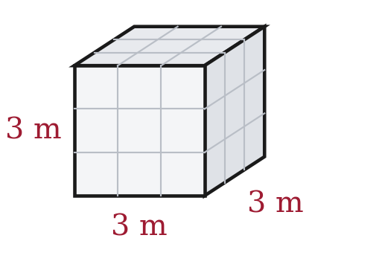

3. A cube-shaped box has a volume of 8 cubic centimeters. How long is one edge?

For questions 4 through 7, find the value.
4. 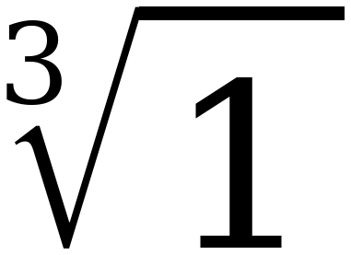

5. 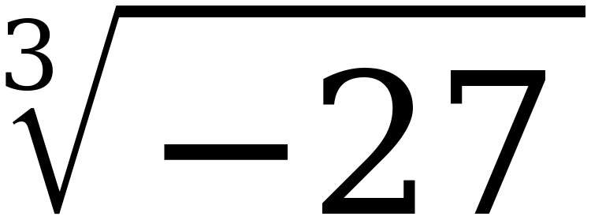

6. 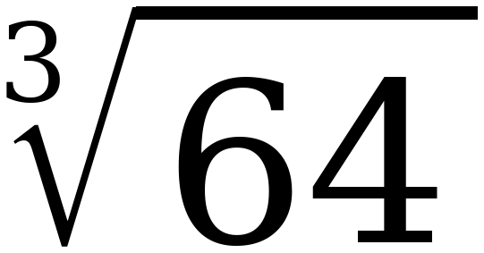

7. 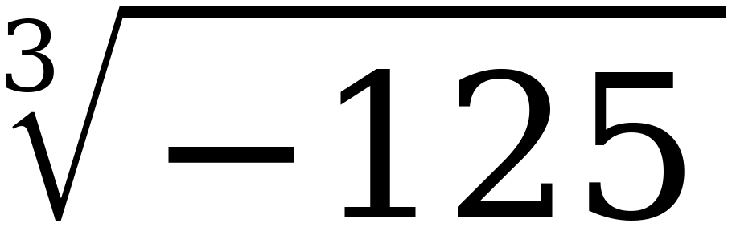

For questions 8 through 10, find every real solution of the equation.
8. x³ = 27

9. a³ = −8

10. w³ = 1

11. Select ALL of the values below that make x³ = 125 true.
☐ | 5 | ☐ | −5
☐ | 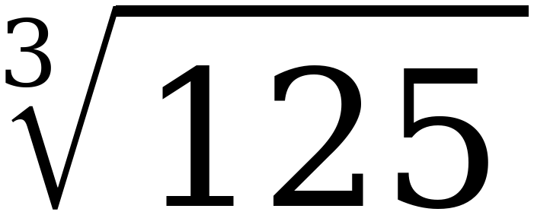 | ☐ | −
☐ | 25 | ☐ | 41⅔

12. Complete the table of values for y = x³. Then plot the five points on the grid.
x | Substitute into y = x³ | Coordinates (x, y)
−2
−1
0
1
2

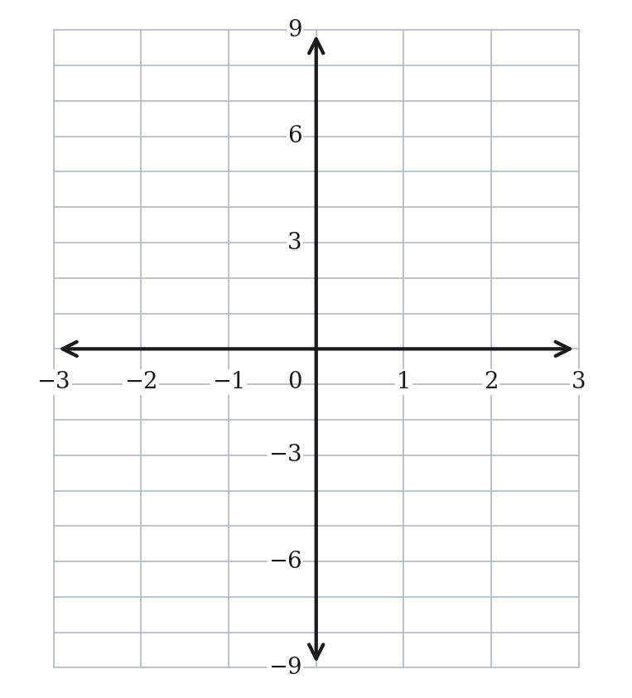
13. The equation x² = 36 has two solutions, but the equation x³ = 27 has only one. Explain why.

STRETCH. The two questions below use cubes larger than the Grade 8 FAST will ask for. The method is identical — only the arithmetic is bigger.
14. 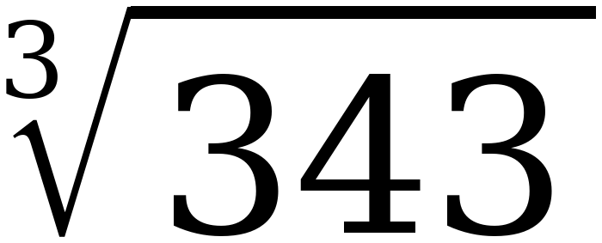

15. m³ = 512

